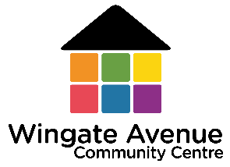
2025 STUDENT TUITION – SKILLS FIRST
YEARLY FEES SCHEDULE
COURSE INFORMATION |  |  | STANDARD FEES  Fee for service - for students not eligible for government funding | FEES  for students eligible for government funding
Course Code | Course Name | Scheduled Hours | Fee for full fee paying student | Tuition Fee for  Non Concession Holder |  | Tuition Fee for  Concession Holder
 |  |  |  | per hour | per year | per hour | per year
FULL YEAR
22636VIC | Course in Initial EAL | 445 | $3,893.75 | $1.10 | $489.50 | $0.22 | $97.90
22637VIC | Course in EAL | 445 | $3,893.75 | $1.10 | $489.50 | $0.22 | $97.90
22638VIC | Certificate I in EAL (Access) | 480 | $3,600.00 | $1.10 | $528.00 | $0.22 | $105.60
22639VIC | Certificate II in EAL (Access) AM | 505 | $3,787.50 | $1.10 | $555.50 | $0.22 | $111.10
22486VIC | Certificate III in EAL (Access) AM | 500 | $3,750.00 | $1.10 | $550.00 | $0.22 | $110.00

The student tuition fees are subject to change, depending on individual circumstances at enrolment.
There is no charge for students seeking Recognition of Qualifications issued by other Registered Training Organisations (RTO’s) for units of competency for the qualifications listed above.

